A….ASIA- Indus-Male figurine-polos headdress-terracotta-3000 BCE

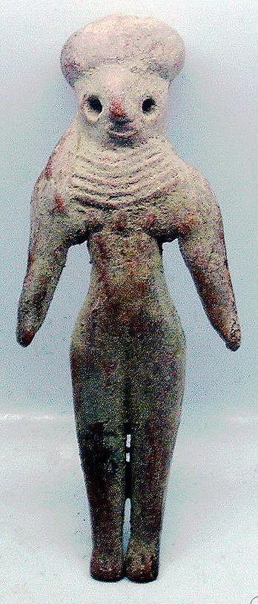 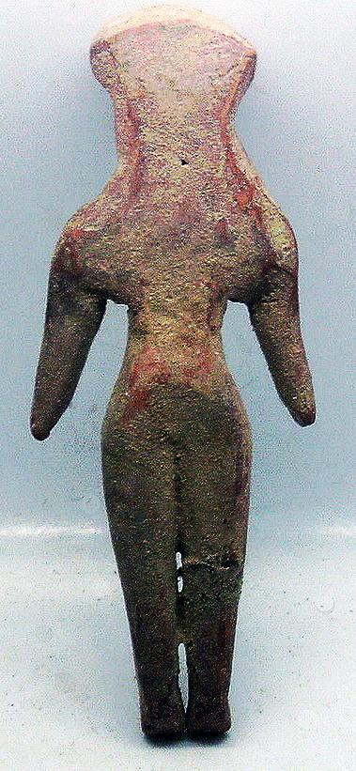

Fig. 1. Indus-Male figurine-polos headdress-terracotta-3000 BCE

Case no.: 3.

Accession Number: A….

Formal Label: Indus-Male figurine-polos headdress-terracotta-3000 BCE

**Display Description:**

This Indus Male figurine wears a polos headdress. Its general demeanor suggests an importance to the community. This male is characterized by his stylized facial features and long lappets of hair, which hang down on past the shoulders. Eyes are large and round with deeply incised large pupils. The long tapered legs end with delicate little feet with individual toes pointed downward.

**LC Classification:** PK119

Date or Time Horizon: 3000 BCE

Geographical Area: Indus Valley

INCLUDEPICTURE "https://upload.wikimedia.org/wikipedia/commons/5/50/Carte_Indus.jpg" \* MERGEFORMATINET 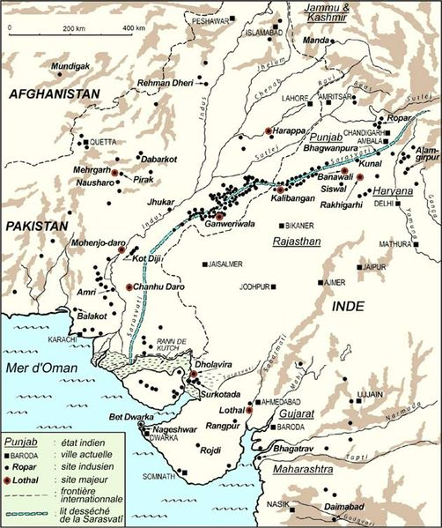

Cultural Affiliation: Indus

Media: terracotta, black pigment

Dimensions: H 10.1 cm.

Weight:

Condition: original

Provenance: Ex: European collection

**Discussion:**   
Figure wears a tall flared polos type headdress. The shoulders are broad and square with her arms extending downwards and slightly out.

**References:**